ICT/Computer Science

Week 3: Mini-project: Introduce yourself! Create your electronic portfolio (e-portfolio)

- Know how to use your school email:
Your email: your school number + @suisqp.com (example: QP12345678@suisqp.com)
Password: QP@your_school_number (example: QP@12345678)
Log in to check your email in Outlook or www.office.com

您的电子邮件：您的学号 + @suisqp.com（例如：QP12345678@suisqp.com）
密码：QP@your_school_number（例如：QP@12345678）
登录 Outlook 或 www.office.com 查看您的电子邮件

- Sign up/Log in: www.canva.cn
If you never used canva.cn before - you need to register (sign up) using your personal or school email address.
You will receive a verification code to your email address.
如果您以前从未使用过canva.cn - 您需要使用您的个人或学校电子邮件地址注册（注册）。
您的电子邮件地址将收到验证码。

- Once you have signed up, use “websites” 注册后使用“网站”
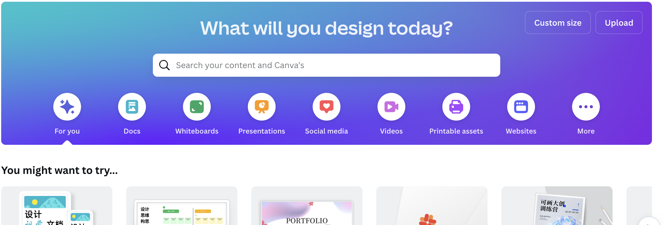

选择任何模板并开始创建您自己的作品集
You need to include the following information:
- Your English name (& photo optional)
- Little introduction about yourself.
- Your expectations from the ICT/Computer science course
- Your favorite subjects, hobbies, achievements.
- Other relevant information.
Note: you can use this page later as a resume/intro about yourself anywhere you go!
Grading info: This year we will have 2 mini-projects and 6 quizzes. Each quiz weighs 10% each project weighs 20% (thus, your mini-project is 20% of the total grade for the year)
You will have 3 weeks to finish your portfolio.

To submit: copy the link to your e-portfolio (make sure you change your privacy settings to “anyone with the link can view”) and send it via email to my address: kamilab@suisqp.com by October, 7

您需要包含以下信息：
1.您的英文姓名（照片可选）
2.关于你自己的简单介绍。
3.您对ICT/计算机科学课程的期望
4.你最喜欢的科目、爱好、成就。
5.其他相关资料。
注意：您以后可以在任何地方使用此页面作为您自己的简历/自我介绍！
评分信息：今年我们将有 2 个小项目和 6 个测验。每个测验占 10%，每个项目占 20%（因此，您的迷你项目占当年总成绩的 20%）
您将有 3 周的时间来完成您的作品集。

提交：将链接复制到您的电子作品集（确保将您的隐私设置更改为“知道该链接的任何人都可以查看”）并在 10 月 7 日之前通过电子邮件将其发送到我的地址：kamilab@suisqp.com

This is an introductory project to assess Quality of work, creativity, ability to use technology.
这是一个介绍性项目，旨在评估工作质量、创造力、使用技术的能力。

