How to create a simple poster in canva:
Sign in/Log in: canva.cn
Use your personal or student email address

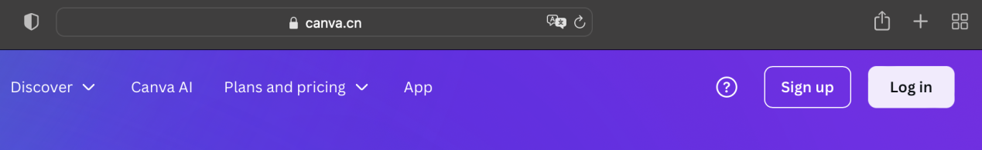

Instructions:
1. Know how to use your school email:
email account is the same as the school number + @suisqp.com (example: QP12345678@suisqp.com)
Password: QP@12345678
Log in to check your email in Outlook or www.office.com

2. Sign up/Log in: www.canva.cn

If you never used canva.cn before - you need to register (sign up) using your personal or school email address.
You will receive a verification code to your email address.

- Once you have signed up, select create“presentation” or “print” to create a poster
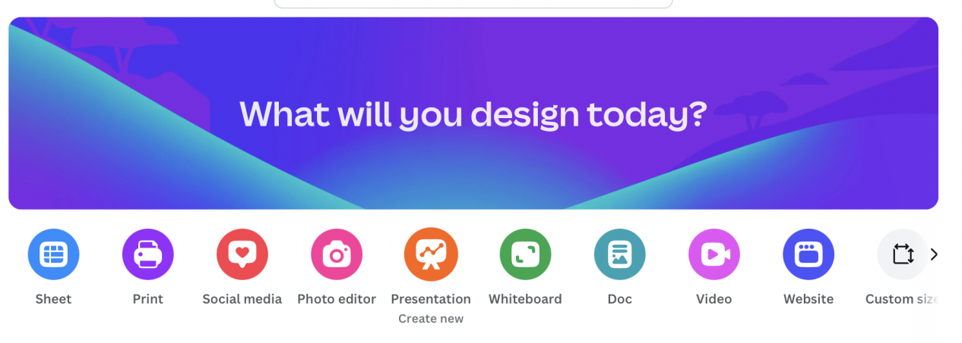
To submit: Include your name, grade, project name (Example: Anna, 6G, Safe internet)

