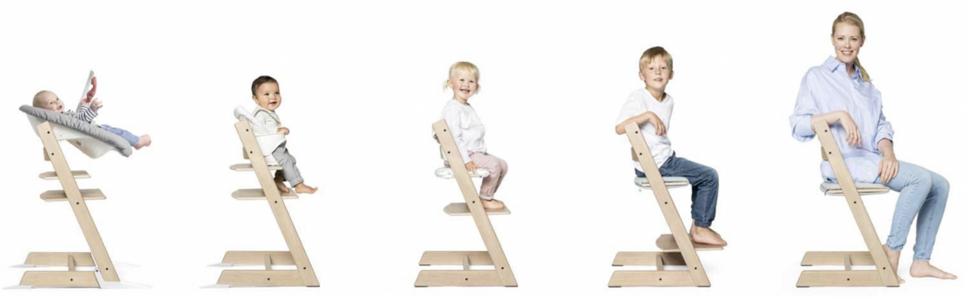

Case Study: Tripp Trapp Chair

Essential Idea:
Products can grow and change with the user

The Tripp Trapp Chair was introduced in 1972 by Scandinavian designer Perter Oversbig. Made out of wood, the chair is unique in that it is designed to grow with the chid. The goal of the design was to ensure the child could sit comfortably at the family table. The designer wanted to ensure children could participate in the family meals, as well as conversation and games at the table. From Stokke.

The Tripp Trapp is really a lifetime addition to your family, from the minute your little one enters our world. An ingenious highchair that revolutionized the children’s chair category back in 1972 when it was first launched. Characterized by simplicity, minimalism and functionality, it is designed to fit right up to your dining table, bringing your baby into the heart of your family, allowing him or her to learn and develop alongside you.

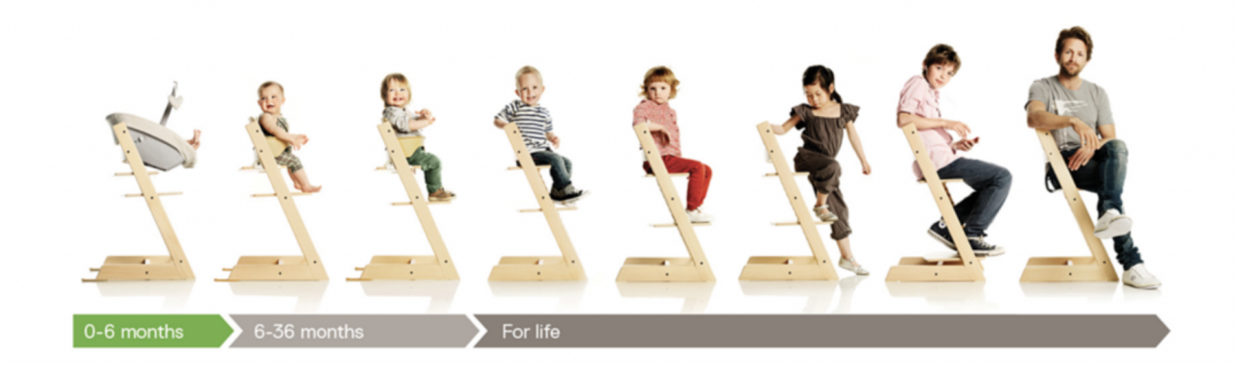
Adjustability is at the heart of the design
From an ergonomic point of view, the chair is designed to be easily adjustable. The footrest and seat can be adjusted as the child grows. Simple slats in the legs allow the seat and the footrest to side in and out. The original design consisted of a 3-point harness and seat cushions, which allowed the chair to be used with younger groups.

Originally designed for children 18 months and older, the chair was marketed to European markets as the Tripp Trapp Chair. However, in 2006 Stokke entered the US market and marketed the chair under the Kinderzeats name.
Changes Driven by Safety
This introduction to the US market was also accompanied by several changes to the design, mostly to address safety regulations and concerns. First, in 2008 the US version of the chair was rebranded as Tripp Trapp Chair to align it with the Stokke’s global branding strategies. More importantly, the safety harness and baby-rail were introduced to meet safety concerns and regulations. The Baby Rail was another addition that kept the young child well supported and secure in the seat, and was meant to be used in conjunction with the harness. Due to safety and quality concerns, the Baby Rail was redesigned as the Baby Set. The new design included improved back support (a critical feature for very young children) and the harness was changed from a 3-point to a 5-point harness, which increased safety and was similar to the type of harnesses used in car seats for babies. Another addition was the inclusion of small supports that slide out of the base to improve the stability. This feature was in response to concerns that a child seated in the chair at a table could push against the table and tip the chair backwards.

All these changes brought the Tripp Trapp chair inline with features of competing chairs in the US market.

Questions and Reflection
- Outline the ergonomic considerations the designer might have considered in the design of the chair. Identify 3 important ergonomic measurements they would have had to consider.

- Discuss how the designer might have used percentiles in selecting ergonomic data to guide the development of their chair.

- Describe the elements of the design of the Stokke Tripp Trapp Chair could be considered a type of classic design.

- Outline the features of the chair that contribute to it being considered a sustainable design.

5. Describe how the adjustability of the chair contributes in a positive way to sustainable consumption.

6. Identify the unique aspect of the Stokke Chair with regards to the

7. Identify the market research strategies that Stokke might have used to make changes to the branding and design of the Tripp Trapp Chair for the US market.

- Outline how regulations can impact the design of a product.

Analyzing for Innovation
The Tripp Trapp chair is unique in that it is designed to grow with the user, from infancy to adulthood.

Users needs change over time - Physically they might get larger as they age, or conversely, experience a reduced range of motion. What types of products that we constantly replace throughout our life that could be redesigned to achieve the same goal as Tripp Trapp Chair.

Design challenge:
How might we design a product that evolves with the user as their body and/or needs change over time?

