Answers to the Review of Chapters 1.2-1.3
The purpose of the worksheet is to help you prepare for the upcoming test.
Please write down the answers to your notebooks.
If you are struggling - read Chapters 1.1-1.3, or go over the lecture slides. Make sure you understand the concepts and know the answers to these questions before attempting the test.
工作表的目的是帮助您为即将到来的考试做好准备。
请将答案记在您的笔记本上。
如果您遇到困难 - 请阅读第 1.1-1.3 章，或查看讲座幻灯片。在尝试测试之前，请确保您理解概念并知道这些问题的答案。

- Flowcharts, variables.
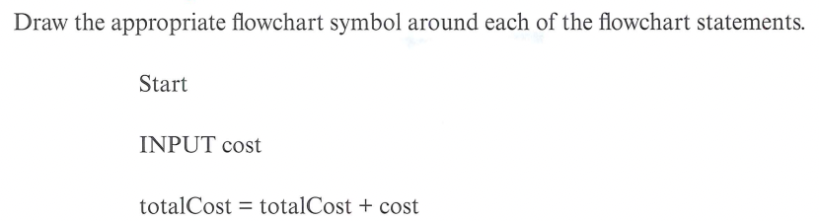

- Selection in flowcharts
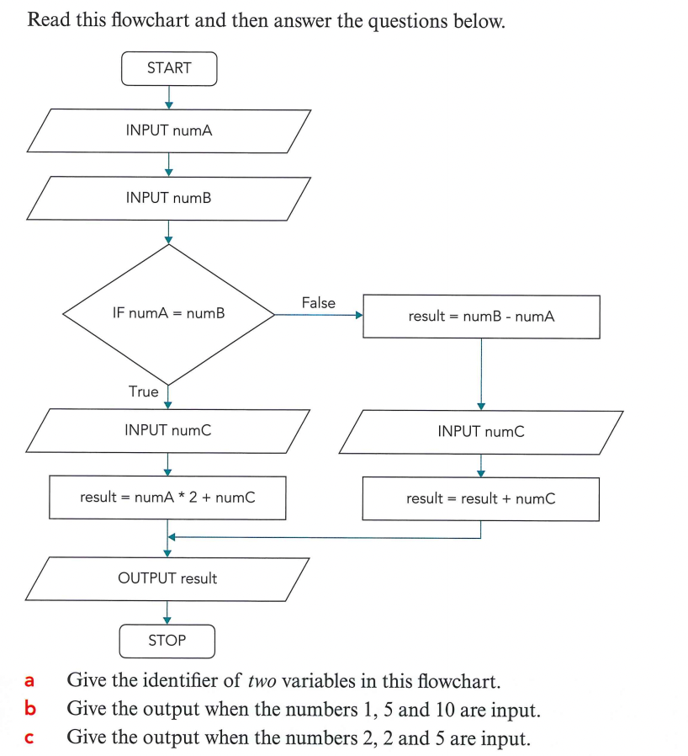

- identifier = name of a variable, example: numA, numB, numC, result
- 14
- 9

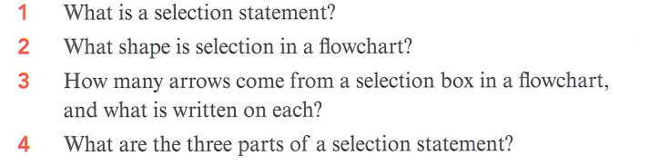
- A statement that is used when a decision has to be made. It has a condition.

- Diamond

- two

- 1. condition, 2. action that happens when condition is true, 3. action that happens when condition is false

- Boolean Operators:
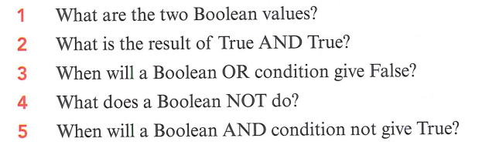
- True (1), false (0)
- True AND True = True (1 & 1 = 1)
- False OR False = False (0 II 0 = 0)
- inverts the result (gives the opposite) example: if 1 then 0
- True AND False = False, False AND True = False, False AND False = False (1&0 = 0, 0&1 = 0, 0&0 = 0)

- Sub-routines:

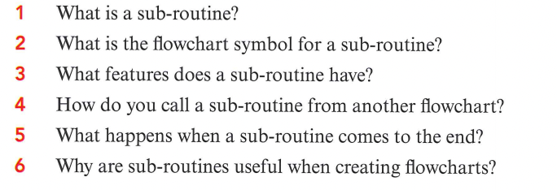

- Subroutine (procedure, function) - a small, separate section of code that performs a specific task. Can be used repeatedly throughout a program

- identifier, call, return
- by using an identifier in the main code
- the algorithm returns to where it stopped in the main code
- You can write once and use it many times.

