Fan with Motor
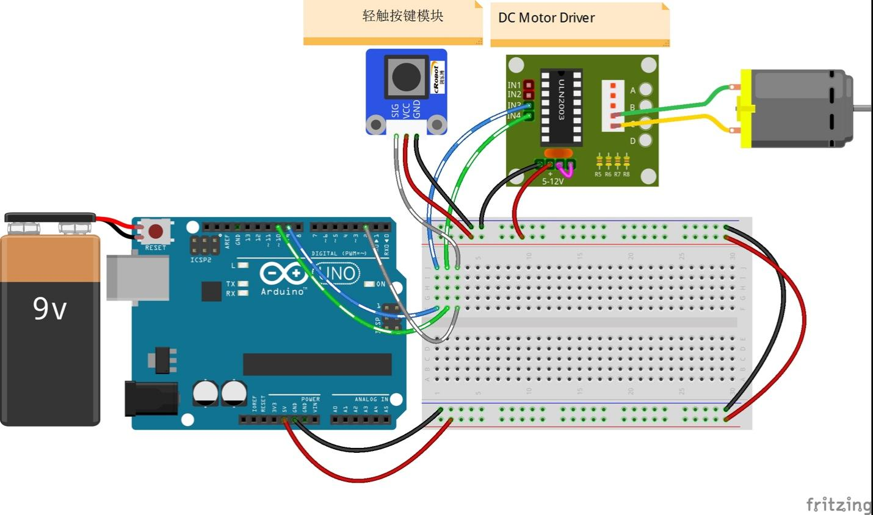
Code
//Small Fan
/****************************************************************
* As explained above, the amount of times you press the button should change the rotation speed of the fan.
* Pressing it once will cause it to rotate slowly,
* while pressing it three times will cause it to rotate quickly, and pressing it four times will cause it to stop.
****************************************************************/

// constants won't change. They're used here to
// set pin numbers:
const int buttonPin = 2; // the number of the pushbutton pin
const int ledPin = 13; // the number of the LED pin
const int motorIn1 = 9;
const int motorIn2 = 10;
int stat = 0;
#define rank1 150
#define rank2 200
#define rank3 250
// Variables will change:
int buttonState; // the current reading from the input pin
int lastButtonState = LOW; // the previous reading from the input pin

// the following variables are long's because the time, measured in miliseconds,
// will quickly become a bigger number than can be stored in an int.
long lastDebounceTime = 0; // the last time the output pin was toggled
long debounceDelay = 50; // the debounce time; increase if the output flickers
/******************************************************************************/
void setup()
{
//set theled,motors as OUTPUT,button as INPUT
pinMode(buttonPin, INPUT);
pinMode(ledPin, OUTPUT);

pinMode(motorIn1,OUTPUT);
pinMode(motorIn2,OUTPUT);
Serial.begin(9600);
}

void loop() {
// read the state of the switch into a local variable:
int reading = digitalRead(buttonPin);
if (reading != lastButtonState)// If the button state is different from last time
{
lastDebounceTime = millis();// reset the debouncing timer
}
if ((millis() - lastDebounceTime) > debounceDelay)
{
if (reading != buttonState)
{
buttonState = reading; // Store the state of button in buttonState
// only toggle the LED if the new button state is HIGH
if (buttonState == HIGH)
{
digitalWrite(ledPin, HIGH); //turn on the LED
stat = stat + 1;
if(stat >= 4)// When stat>=4, set it as 0.
{
stat = 0;
}
}
else
digitalWrite(ledPin, LOW);
}
}
switch(stat)
{
case 1:
clockwise(rank1);// When stat=1, set the rotate speed of the motor as rank1=150
break;
case 2:
clockwise(rank2);// When stat=2, set the rotate speed of the motor as rank1=200
break;
case 3:
clockwise(rank3);// When stat=3, set the rotate speed of the motor as rank1=250
break;
default:
clockwise(0);// else, set the rotate speed of the motor as rank1=150
}
// save the reading. Next time through the loop,
// it'll be the lastButtonState:
lastButtonState = reading;
}
/***********************************************************/
void clockwise(int Speed)//
{
analogWrite(motorIn1,0);
analogWrite(motorIn2,Speed);
}
/***********************************************************/

