Review of Chapters 1.2-1.3
The purpose of the worksheet is to help you prepare for the upcoming test.
Please write down the answers to your notebooks.
If you are struggling - read Chapters 1.1-1.3, or go over the lecture slides. Make sure you understand the concepts and know the answers to these questions before attempting the test.

- Flowcharts, variables.
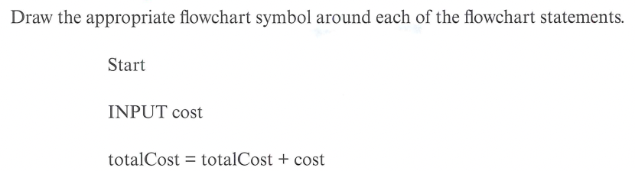

- Selection in flowcharts
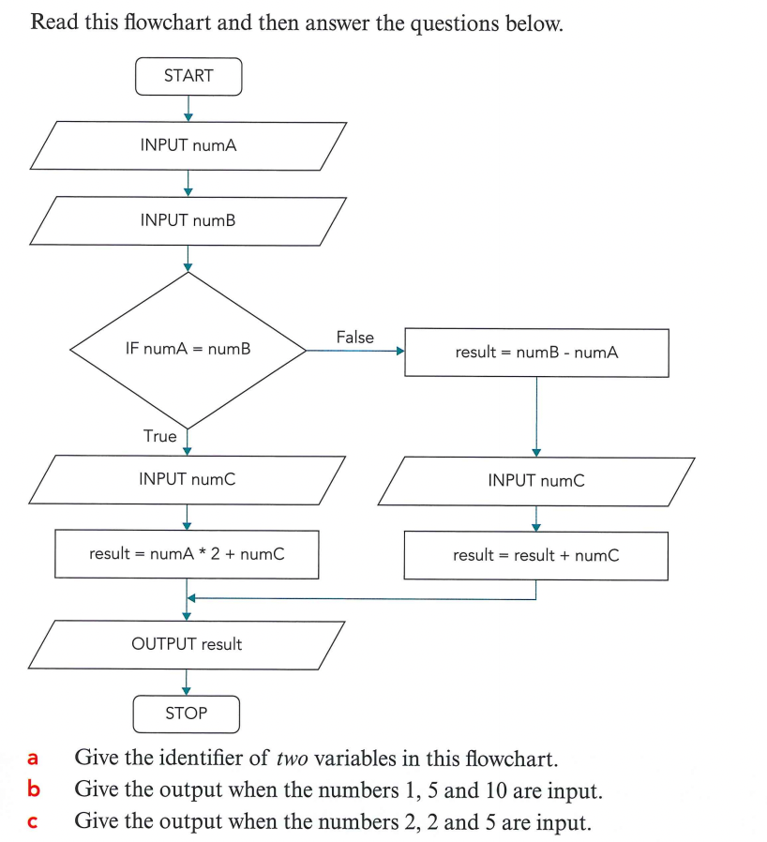

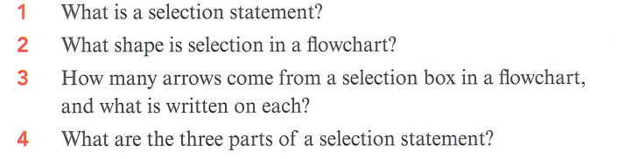

- Boolean Operators:
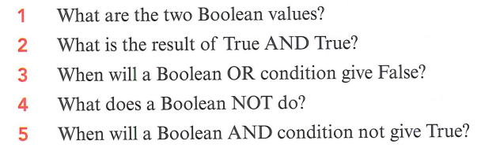

- Sub-routines:

