Buzzer

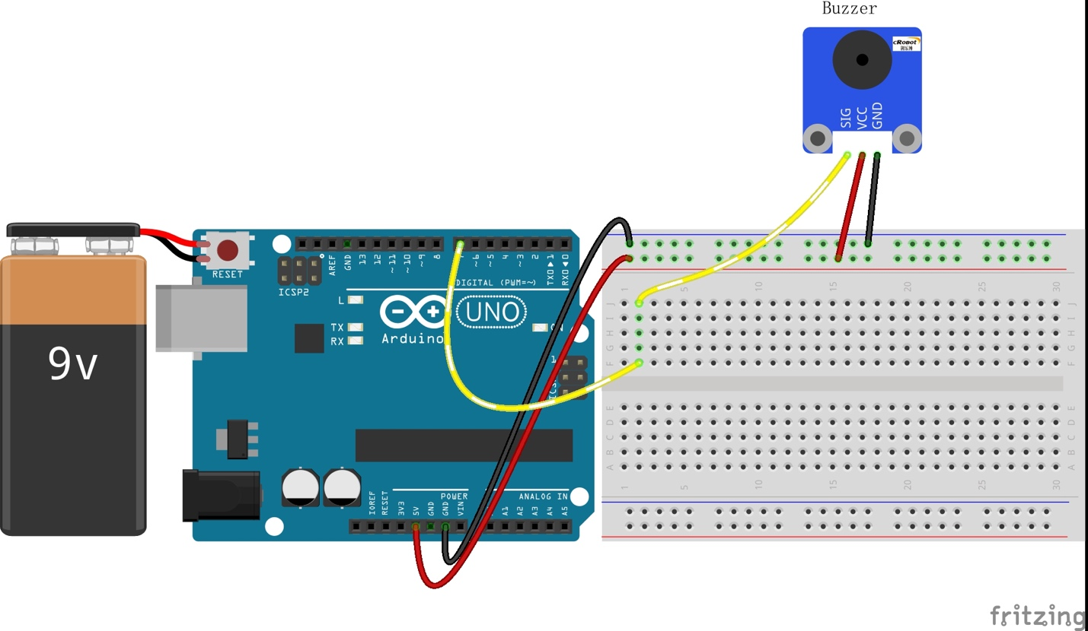

CODE:

int buzzerPin = 7;//the pin of the active buzzer attach to pin7
void setup()
{
pinMode(buzzerPin,OUTPUT);//set the buzzer as as OUTPUT
digitalWrite(buzzerPin,LOW);//initialize the buzzerPin as LOW level
}
void loop()
{
digitalWrite(buzzerPin,LOW);
delay(1000);
digitalWrite(buzzerPin,HIGH);
delay(1000);
}

