Name:
FILL OUT: Instruction to create a flag in spreadsheets (在电子表格中创建标志的说明):

Task:
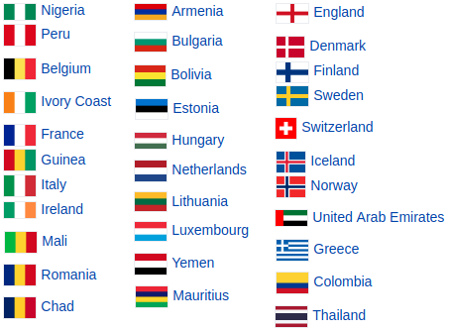
- Choose ONE flag and color it by filling in cell colors in excel/WPS spreadsheets/table.
- Write down the instructions on how to create this flag and your name in this document above. (Don’t write down what country’s flag you have created.)
- Once you finish, save this document and send it to your teacher’s computer.
- Your teacher will send your instruction to another (random student). This student will have to follow your instruction and guess the name of the flag they have created by following your instructions. You will also receive someone else’s instructions.
1. 选择一面国旗，并通过在 Excel/WPS 电子表格/表格中填写单元格颜色来为其着色。
2. 在本文档中写下如何制作这面国旗的说明以及你的姓名。（不要写下你制作的国旗是哪个国家的。）
3. 完成后，保存此文档并将其发送到老师的电脑上。
4. 你的老师会将你的说明发送给另一位（随机选择的学生）。该学生需要按照你的说明，猜出他们制作的国旗的名称。你也会收到其他人的说明。

Example:
Name: Kamila B.
Instruction: Apply a black fill colour to the following cells:
●A1:F5
Apply a red fill colour to the following cells:
●A6:F10
Apply a yellow fill colour to the following cells:
●A11:F15

示例：
姓名：Kamila B.
说明：将以下单元格填充为黑色：
●A1:F5
将以下单元格填充为红色：
●A6:F10
将以下单元格填充为黄色：
●A11:F15

