Design Technology 7A
Week 4: Unit 1 CAD/CAM “Happy birthday, SUIS QP!”

This week we start exploring Tinkercad 3D design software.
Going through its Learning Center Tutorials will help us develop (from basic to intermediate) 3D desigining skills: https://www.tinkercad.com/learn
We will be going through the turorials at our comfortable speed, however, following all the important deadlines.

本周我们开始探索 Tinkercad 3D 设计软件。
学习中心教程将帮助我们发展（从基础到中级）3D 设计技能：https://www.tinkercad.com/learn
然而，我们将按照所有重要的截止日期，以我们舒适的速度完成图会。

A few rules, when we will be using technology:
- We will NOT be playing games.
- We will NOT be opening irrelevant to the lesson websites, apps.
- We will keep drinks and food away from our devices.
- Remember our passwords, and keep them private.
- We make sure our hands are clean before using the devices.
- We report any issue immediately.
- We will be keeping our bodies calm (no running, jumping, pushing)
- We won’t be distracting our classmates and focusing on our own work.

当我们使用技术时，有一些规则：
1.我们不会玩游戏。
2.我们不会开放与课程无关的网站、应用程序。
3.我们会让饮料和食物远离我们的设备。
4.记住我们的密码，并保密。
5.我们在使用设备之前确保双手清洁。
6.我们立即报告任何问题。
7.我们要保持身体平静（不要跑、跳、推）
8.我们不会分散同学的注意力，专注于自己的工作。

To log-in into Tinkercad follow the next steps:

Go to https://www.tinkercad.com/joinclass
Enter the class code: **********
Enter your Nickname assigned by your teacher.

要登录 Tinkercad，请按照以下步骤操作：

转到 https://www.tinkercad.com/joinclass
输入班级代码：************
输入老师指定的昵称。

In parallel to the tutorials each group will search for an existing 3D design in an online repository and print according to the following schedule:

在学习教程的同时，每个小组将在在线存储库中搜索现有的 3D 设计，并根据以下时间表进行打印：

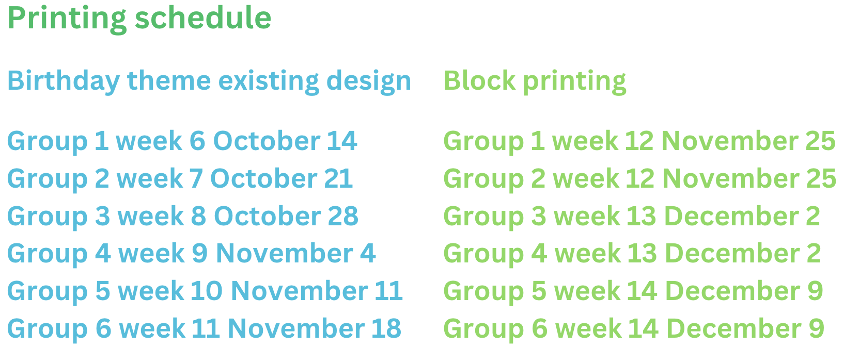
After printing the existing object, each group would need to print two word blocks designed by everyone in the group in Tinkercad (printing according to the schedule on the right side.)
打印现有的对象后，每个小组需要在Tinkercad中打印两个小组中每个人设计的字块（按照右侧的时间表打印。）

