Sound Sensor
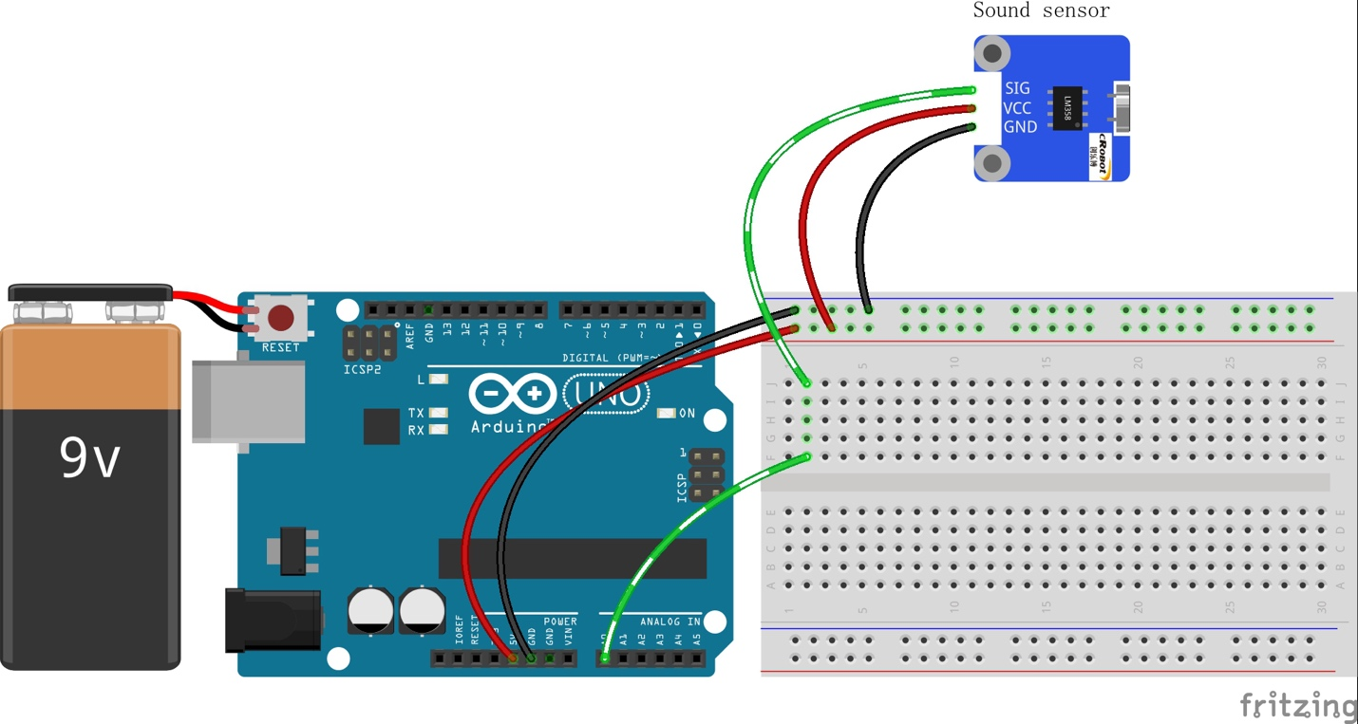
Code
/************************************************* **
name:Rotary Encoder
function:you can see the angular displacement of the rotary encoder printed on Serial Monitor.
When the rotary encoder rotates clockwise, the angular displacement increases; when it does counterclockwise, the value decreases.
Press the switch on the rotary encoder, the value will return to zero.
********************************************************/
const int ledPin = 13; //pin13 built-in led
const int soundPin = A0; //sound sensor attach to A0

void setup()
{
pinMode(ledPin,OUTPUT);//set ledPin as OUTPUT
Serial.begin(9600); //initialize the serial communication as 9600 bps
}

void loop()
{
int value = analogRead(soundPin); //read the value of sound sensor
Serial.println(value);//print it
if(value > 600)//if the vallue of sound sensor is greater than 600
{
digitalWrite(ledPin,HIGH); //turn on the led
delay(200); //delay 200ms
}
else //elae
{
digitalWrite(ledPin,LOW); //turn off the led
}
}

