Traffic Light

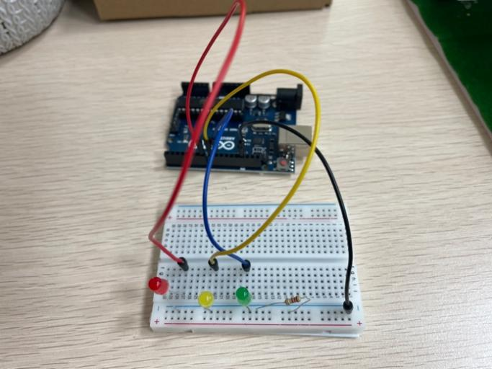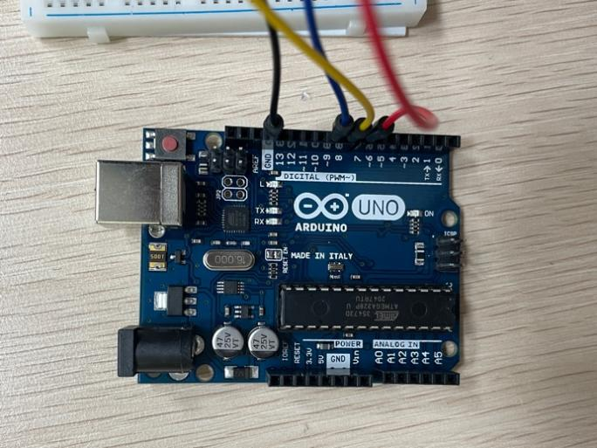

CODE:
void setup()
{
pinMode(7, OUTPUT);
pinMode(8, OUTPUT);
pinMode(9, OUTPUT);
}
void loop()
{
digitalWrite(7, HIGH);
delay(5000);
digitalWrite(7, LOW);
delay(500);
digitalWrite(8, HIGH);
delay(500);
digitalWrite(8, LOW);
delay(500);
digitalWrite(8, HIGH);
delay(500);
digitalWrite(8, LOW);
delay(500);
digitalWrite(8, HIGH);
delay(500);
digitalWrite(8, LOW);
delay(500);
digitalWrite(8, HIGH);
delay(500);
digitalWrite(8, LOW);
digitalWrite(9, HIGH);
delay(5000);
digitalWrite(9, LOW);
digitalWrite(8, HIGH);
delay(500);
digitalWrite(8, LOW);
delay(500);
digitalWrite(8, HIGH);
delay(500);
digitalWrite(8, LOW);
delay(500);
digitalWrite(8, HIGH);
delay(500);
digitalWrite(8, LOW);
delay(500);
digitalWrite(8, HIGH);
delay(500);
digitalWrite(8, LOW);
delay(500);
}

