Worksheet for Chapter 1.1-1.3 Introduction to Computer Science: Flowcharts, Variables, and Logic
A flowchart is a diagram that shows the steps in a process using different shapes and arrows. In computer science, we use flowcharts and pseudocode to plan programs before writing them. Important ideas include variables (which store data), assignment (giving a value to a variable), input (getting information), output (showing information), arithmetic operators (like +, −, *, /), and Boolean logic (like AND, OR, NOT) for decision-making. Selection statements like IF THEN and ELSE help computers make decisions based on conditions. Sub-routines are smaller chunks of code that can be called to perform specific tasks, making programs more efficient. Recognizing patterns helps us solve problems by repeating or reusing code.

Fill in the Blank
Fill in the blank with the correct words.
In a flowchart, a rectangle shape usually shows a _____________.
A variable is used to _____________ information in a program.
The _____________ operator checks if two values are equal.
An IF THEN statement is used to make a _____________ in a program.
The word used to describe a name given to a variable is _____________.
Word Bank: process, identifier, store, comparison, decision

Multiple Choice Questions
Choose the correct answer from the choices for each question.
Which symbol is used in a flowchart to represent an input or output operation?
a) Diamond
b) Parallelogram
c) Rectangle
d) Arrow
What is the purpose of a sub-routine in programming?
a) To store numbers
b) To repeat a specific task
c) To make decisions
d) To show output
Which of the following is a Boolean operator?
a) ADD
b) IF
c) OR
d) INPUT
What does the assignment operator do?
a) Compares two values
b) Declares a variable
c) Gives a value to a variable
d) Returns from a sub-routine
What is pseudocode?
a) A programming language
b) A way to write code using only numbers
c) A simple way to plan a program using plain language
d) A type of Boolean operator

Open-Ended Questions
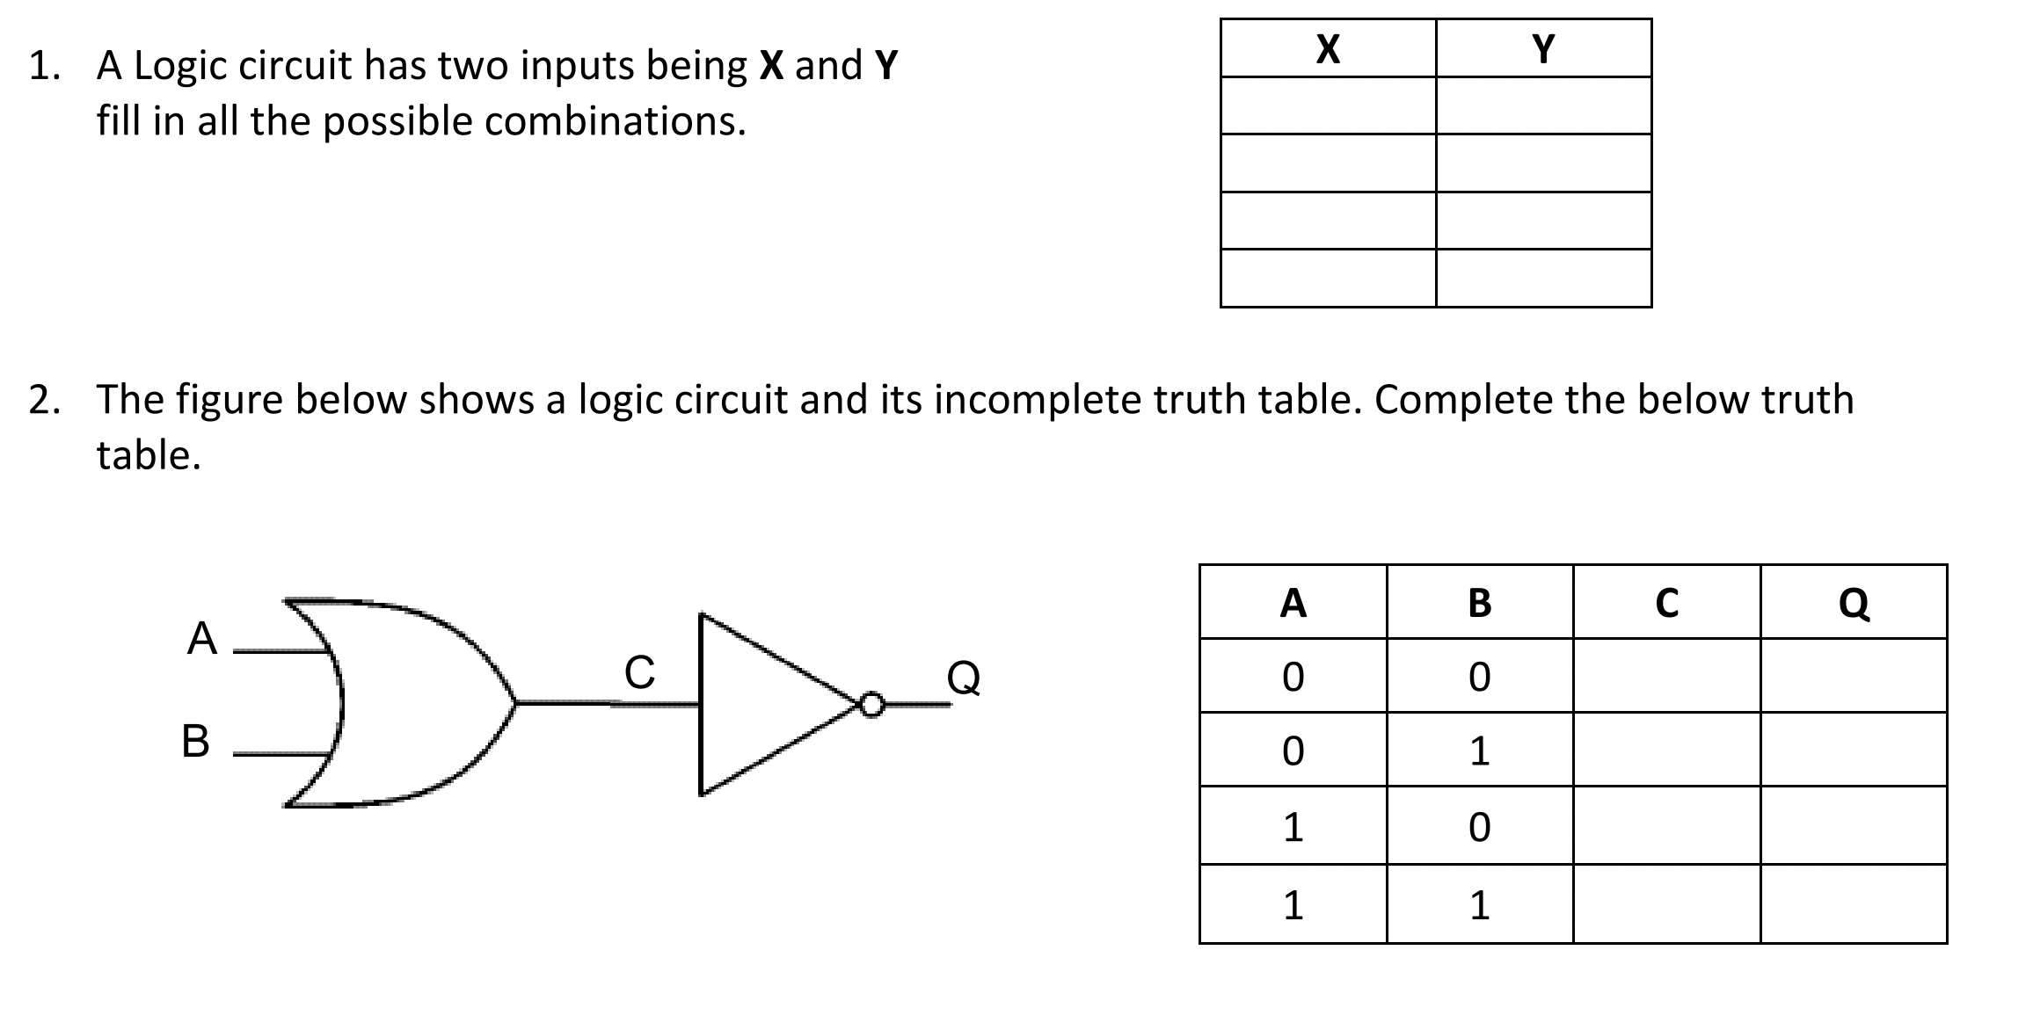
3. Why is it important to use sub-routines when writing longer programs?

